A report on

Bus Schedule Management And

Route Wise Load Tracking System

Submitted by

Kollapaneni Bhavya Chowdary-20BCS116

Gurram SaiEesha-20BEC042

Godavarthi Hemanvitha-20BCS089

CSE,2024

Submitted to

Prof.Pritee Khanna



PDPM INDIAN INSTITUTE OF INFORMATION

TECHNOLOGY, DESIGN AND

MANUFACTURING JABALPUR,INDIA

November 16th,2021

1. Introduction

2. Purpose & Scope

3. Users

4. Overall Description

a. System Features and Requirements

b. Functional Requirements

c. External Interface Requirements

d. Non-functional Requirements

5. Technology Used

6. Database Designing

a. Entity Relationship Diagram(ERD)

7. Project Screenshots

1. Introduction

The name of our project is Bus schedule management system and Route wise load tracking system in IIITDMJ. Buses are the most frequently available and most used vehicle for going from small distance trips to very long trips. This project is to implement the bus schedule management and route wise load tracking system in IIITDMJ.

1. Purpose & Scope

The Bus Management System is being developed to provide a tool for our college to easily maintain the college bus information. At the start of the project setup, it provides an interactive part to store information about buses; different routes of buses, Schedule information, and seats available etc.

During the period of finalizing the idea of the system,the primary goal was to design the system that will be easy to use for those who don’t know how to handle the software. As designing work began and things started taking shape, the system got developed to a stage where it would be used by entry level.

Bus Management System will include the buses information, driver's

information. Search function are also added so that user can search

for bus information that has been stored in the databases.

Any colleges/schools/travelling agencies can make use of this

application providing information about the location of the vehicles.

this system would provide basic set of features such as adding or

updating routes and locations in the database.

1. Users

* Admin
* Student

1. Overall Description

a. System Features and Requirements :

* The system wants a minimum of two GB of ram to run all the options sleek and unforeseen.
* It wants a minimum 1.3 gigahertz processor to run smoothly as else which will produce issues.
* The system must be operated by some approved person as wrong hands will build it happy-go-lucky.
* Rest is all up to the user’s usage can take care of the hardware.
* For security opposing anti-virus is suggested.

b. Functional Requirements

The functional requirements of the bus management system are those requirements that are necessary to the eye of the user and the client.

* Registering User
* Updating User
* Login

**Functionality and modules of the project:**

* Admin – This module is used for admin login
* Logout functionality
* Change Password Functionality

**Features of Bus Module:**

* Admin can add new Bus records
* Admin can see the list of Bus details
* Only admin can edit and update the record of the bus
* Admin will be able to delete the records of the Bus

**Features of Admin Module:**

* Admin can add new login records
* Admin can see the login details
* Only admin can edit and update the record of the Login
* Admin can change the password

**Bus Management Module:**

* Adding New bus details
* Edit the Existing bus details
* View all the details of the Buses
* Listing of all buses

1. External Interface Requirements

Software Requirements:

* Visual Studio
* XAMP SQL Server
* Operating System
* Windows 10

Hardware Requirements:

* PC with dual core or more processor
* 1 GB RAM or Above
* 180GB Hard Disk or Above

d. Non - functional Requirements

* Reliability: The application should be reliable and it should generate all updated information in correct order.
* Availability: Application will be available and working properly for all the time.
* Security

1. Technology Used

* HTML: Page layout has been designed in HTML​
* CSS: CSS has been used for all the designing part ​
* JavaScript: All the validation task and animations has been done using javascript
* PHP: All the business and frontend logic has been implemented ​
* MYSQL:MySQL database has been used as database for the project​
* Apache2: Project will be run over the Apache2 server​
* You can run this project on XAMP, LAMP, WAMP or MAMP​

1. Database Designing
2. Entity Relationship Diagram

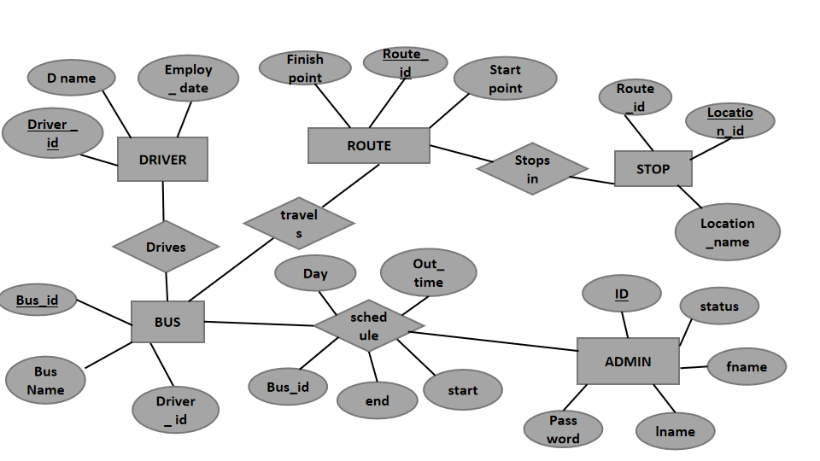

1. ProjectScreenshots